**SUPER POLYGON , A NEW SALE**

**ATTENTION INVESTMENTS**

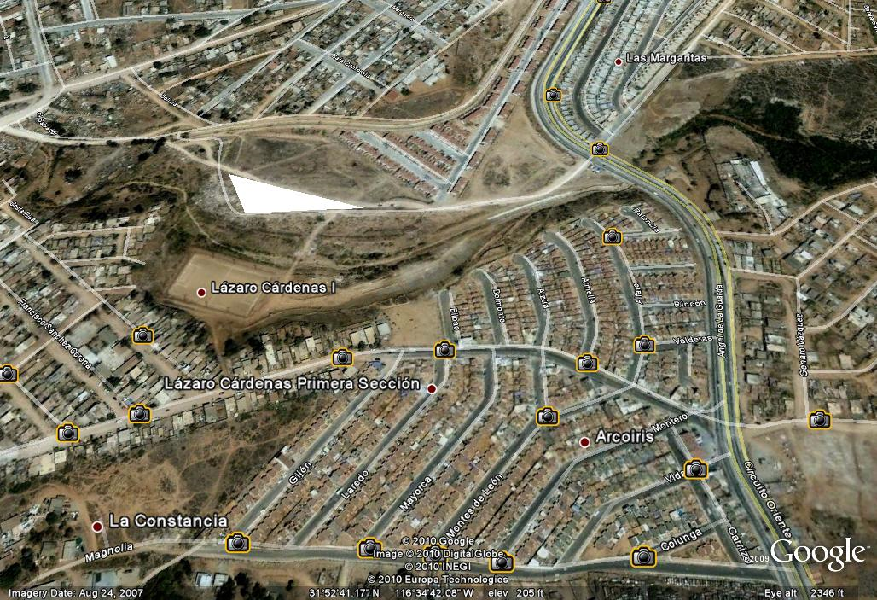

ALL PUBLIC SERVICES , BEST LOCATION FOR MAKE A MALL OR BUILT HOMES , OR WHATEVER YOU WANT ¡!!!!!!!!!!!!

* ***104,000 Acres or 42,000 Has BUT PAY ONLY 60,000 Acres or 24,000 Has PROFIT AREA ONLY***

FEEL FREE TO CONTACT ME [ing_jesusop@hotmail.com](mailto:ing_jesusop@hotmail.com) or [jesus.ortega8@gmail.com](mailto:jesus.ortega8@gmail.com)

**Best price**